IFG Adventure – 3rd Year

Term Three - Week Seven: Plantz Interest
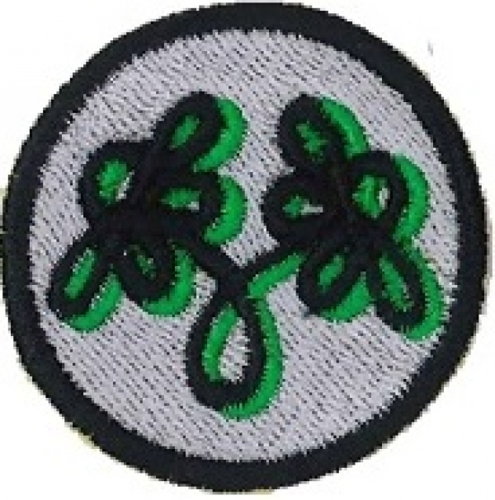
Aim:
- To teach the girls the skills of basic gardening

Coaches Tip:
As it is unlikely the girls will actually achieve all the objectives for Plantz over the three week period, I would suggest a leader be responsible for making sure the girls have some fully grown sample plants. This would give them the incentive to watch the growth progress of the plants.

Objectives:
- To visit a park or garden
- To teach the girls how to grow successful plants
- To have the girls grow plants from seeds

Preparation:
- Notice about this trip should have been given out the week before
- Ensure transport is organized to park or gardens.
- Seek permission to take small soil samples from Park or gardens
- Have a supply of plastics gloves for the girls and leaders

SetUp:
This is your usual formal start to the evening programme, girls will assemble at the Home Zone for marking the roll etc.
Have necessary equipment ready to put in vehicles for the outing.

Equipment needed:
- 1 scoop/small trowel per girl
- 1 shoe box lid per girl
- 3 markers or ice block sticks per girl
- Plastic bags to line lids and to hold collected soil samples
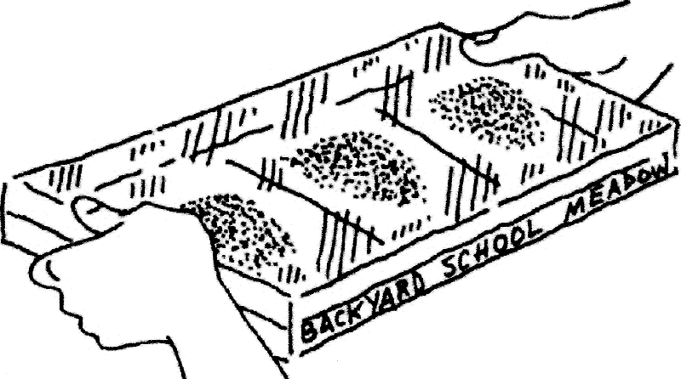
- Plastic wrap
- Scissors
- Water
- Cellotape

Activity:
Visit to Park or Gardens to gather soil samples to make a Secret Seed Garden.
Seeds are all around us, just waiting in the soil to grow. By gathering dirt from several areas, you can grow a garden and see what pops up from those secret seeds.
- Collect several spoonfuls of dirt from three different places. Keep the samples of soil separate.
- Divide the inside of a shoe box lid into three sections, and mark them off with a marker or ice block stick.
- Label each section with the name of the place where you collected the soil sample.
- Line the lid with a plastic bag that has been cut open or a piece of plastic wrap.
- Place each sample of soil in the section with its place name. Sprinkle water over the soil in each section.
- Cover the lid with a piece of plastic wrap or another plastic bag. Seal the cover with tape to create a greenhouse.
- Set the lid in a sunny window, and check every day or two for signs of any plants growing from secret seeds.

Devotion:
(This devotion could be taken as the girls are setting up their secret gardens using the scripture below)
Scripture:
Seed (Creation) - Genesis 1: 11-13
"Then God said, ‘let the land produce vegetation: seed-bearing plants and trees on the land that bear fruit with seed in it, according to their various kinds.' And it was so. The land produced vegetation: plants bearing seed according to their kinds and trees bearing fruit with seed in it according to their kinds. And God saw that it was good. And there was evening, and there was morning - the third day."
Prayer

Notices

Home

IFG Adventure – 3rd Year
Term Three – Week Eight: Plantz Interest


Objective:
- To help the girls understand that some plants can be very strong and so need to be put in the right place in a garden or park.

Preparation:
- Gather together resources for this sessions activity (see list below)
- Soak beans overnight – enough for all girls

Pre SetUp:
- Have a table set aside for drying the containers with plaster of paris. Ensure you have enough tables for the girls to stand around. Cover the tables with plastic sheeting or several layers of newspaper.

SetUp:
Commence the formal part of the evening with roll call etc.

Devotions:
Suggested scripture: Luke 8 v 1-15 Parable of the Sower – this could be an opportunity to talk about the weeds that choke the seeds.
Prayer

Game:
Find the Seed Sowers in the Paddock
Equipment
- Two empty tins or plastic bottles
- Two blindfolds
- Some seeds
How to Play:
- Two players volunteer to be the ‘sowers'.
- Everyone else forms a large circle round them.
- The two sowers are then blindfolded and led to opposite parts of the circle.
- Each is given a tin with seeds in it.
- The leader spins each sower around a few times.
- On the word 'Go’ each sower has to try and locate the other.
- Players keep them both within the circle.
- Every now and then, a sower will shake her tin or plastic bottle (her 'rattle'). When she does so, the other sower must at once shake hers. This will help them find each other.
Winning The first sower, to touch the other wins that round.
Two more 'sowers' are selected and another round is played.

Teaching Sessions:
Plant power experiment:
Plants have amazing power. You might think that rocks would be stronger than plants, but plants are strong enough to break through rock. This experiment will show you how strong plant power can be.

Equipment:
- Plastic Sheeting
- Lots of Newspaper
- Beans – enough for each girl
- Water
- Plaster of paris
- Food colouring (optional)
- Bowls or ice-cream containers for mixing plaster of paris
- Plastic or tin foil containers 8 to 10 cm deep

What to do:
- Soak beans in water overnight.
- Mix plaster of paris – you could add some food colouring if you wish to have a colourful experiment.
- Pour plaster of paris into the aluminum foil baking pan. The plaster of paris should be about 5cms deep.
- Sprinkle the soaked beans on top.
- Cover the beans with another layer of plaster of Paris about 2.5 cm thick.
- Watch what happens. When the beans sprout, they will break right through the rock-like plaster of Paris. (This may take some time so the girls can take them home and bring them back when the beans have sprouted.)

You can see examples of this in nature. When you go for a walk, look for plants and trees growing up through rock, or tree roots breaking up a concrete footpath.

Finish the session with another game of Find the Seed Sower in the paddock.

Closing prayer

Notices

Home

Term Three – Week Nine: Plantz Interest

Objective:
- To help the girls understand how vine plants can grow anywhere
- To let the girls understand that growing plants can be fun.

Preparation:
- Gather together equipment for both of the planned activities - including
- Smooth round stones that have been washed and dried, and
- Enough growing cucumber plants for each girl

Pre SetUp:
- Ensure you have enough tables for the girls to stand around. Cover the tables with plastic sheeting or several layers of newspaper.

SetUp:
Commence the formal part of the evening with roll call etc.

Devotions:
Suggested scripture: John 15 V 1-6
Prayer

Activity Session 1:
Cucumber in a bottle:
(This activity will not take long to complete)
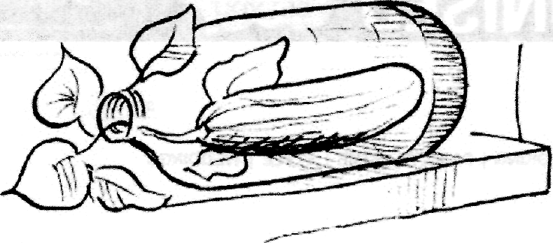
Equipment:
- 2-litre soft drink bottle
- Soil
- Cucumber seeds
- Toothpicks
- Water
- Sunshine
Almost anyone can grow cucumbers in a garden, but you can do something trickier.
It's not as hard as you might think, and your girls will be amazed.
Grow a cucumber in a bottle.
- Take a two-litre plastic soft drink bottle and poke several ventilation holes in it.
- When cucumbers start to develop, gently insert them (still attached to their vines) through the bottle's top.
- Shade the bottle with some cucumber leaves so that the small cucumbers won't cook from too much heat.
- Water every few days and let it get some sunshine

Activity Session 2:
Day and Night Flip Stones
The flip stone shows this with a painted sun on one side and a moon on the other.
Day and night flip stones brighten up any garden.

Equipment:
- Smooth round stones
- Old newspapers

- Acrylic paint
- Paintbrushes
- Water cup
- Clear varnish or nail polish
How to make:
- Find a smooth, round stone. Wash it, and let it dry for several hours.
- Lay out some old newspaper on your work surface.
- On one side of a stone, paint a bright sky-blue background. Make sure you don’t get any paint on the other side of the rock.
- When the blue paint dries, paint a large, smiling sun in the middle of it.
- When that side dries, paint the other side black.
- Add a crescent moon when the black background is dry.
- To protect your painted stones, coat them with clear varnish or nail polish once you have finished painting them. You might want to do two or three coats, waiting for each coat to dry before you add another.
Coaches Tip: You may wish to start with the painting of one side of the stones to allow for drying time.

Games:
While the different layers are drying, play some games.
Suggestions are – twister, knots or any other games the girls enjoy.

Closing prayer

Notices

Home

